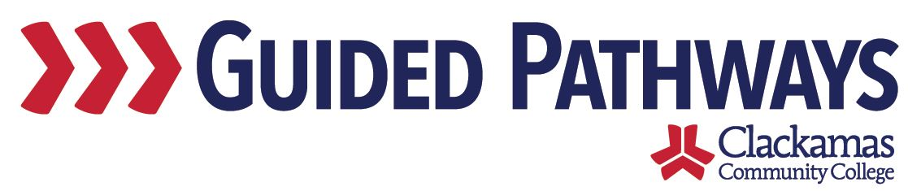
Guided Pathways Leadership Taskforce
Meeting Notes
February 1, 2021, 2:00–3:00 p.m. (Zoom)

- Welcome & Icebreaker Intros
- Icebreaker: share something you’ve been doing to support students, or something you’ve been doing in guided pathways

- Professional Development Outcomes
- Split into breakout rooms to discuss what folks would like the professional development outcomes to be
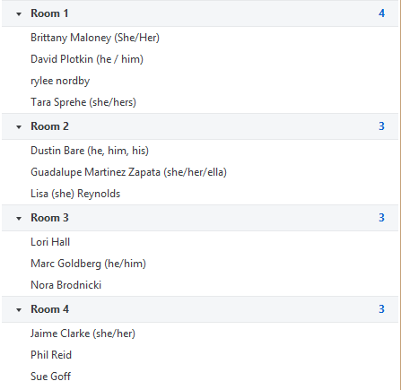
- During the small group discussion, groups updated this Google Doc: https://docs.google.com/spreadsheets/d/1ENTZ_F7Ty1cc_Htk4d1O0AED_WvzzLr0THnbXI4rhZU/edit#gid=1802629036
- Highlights of the small group discussion:
  - Group 1: explore improved teaching – growth mindset, belonging – Navigate training – lack of understanding on what is taught in FYE – more engagement on what guided pathways means for CCC – need students to understand why we’re doing guided pathways and what it means for them – how do we support students (role of faculty)
  - Group 2: decolonizing the classroom pedagogy – transparent assignments – rethink how we do things to help faculty/staff get past punitive attitude toward students “learning their lessons” – use whiteness-questioning framework
  - Group 3: not everyone in the community is familiar with guided pathways, have a Guided Pathways 101 course – recognizing that we have inequitable student learning outcomes that are not the fault of students, how guided pathways can help with achievement gaps – how our non-credit programs fit in with guided pathways – discussed the need for professional development to be interactive
  - Group 4: implementing more culturally relevant/responsive curriculum – transparency framework – understanding the different roles and how it all fits together – how to retain students and keep them on their path – data disaggregation – what supports exists, how do we strengthen supports – growth mindset and self-care, trauma informed care professional development
- Will come back to this discussion in March – look at how we will prioritize these professional development sessions and who will be the primary audience
- If you think of additional items, send them to Dawn and Kelly

- Winter Inservice
- The Biggies are collaborating for Winter Inservice
- Will have about 20 minutes for guided pathways
- Will provide overview, highlight some of the work and accomplishments, show implicit bias video (shown at last month’s GPTF meeting), then go into breakout rooms to discuss how that connects to their work – based on that, what can they continue to work on
- Tara would like to remind the college community that FYE will be mandated and that it is a guided pathways initiative
- Nora discussed the interim equity framework – should it be brought to Curriculum Committee? – Dawn and Nora will have a follow-up conversation on that

- Future Topics/Agenda items for Taskforce
- Gaps – what do we know about them, what are we going to do about them?
- Reenergize the work
- Email ideas to Kelly and Dawn
- Revisit in future meetings

- Updates from GP workgroups
- Workgroup leads shared brief updates on their work

- Review commitments and next steps
- Commitments and next steps were reviewed

